Read the *entire* instructions before you try to follow them. Knowing where you are going will help.

**Show Hidden Characters** (ctrl+alt+i) and the **Highlight Override** feature ([a+] at the top of the Paragraph Style menu). Don’t do anything before turning these on.

# NB: How to Make a New Folder in Box Drive

Once production moves into InDesign, we want to save all the InDesign files together in their own folder, along with a Corrections Log and an oXygen Interventions spreadsheet. **Any images will also be stored in the Edition folder.**

# Images: Intro

All images need to be properly linked in InDesign documents. This means that they must be imported separately from the surround word documents, not just copied/pasted in. Thus, it’s important to be able to recognize the difference between an image that’s been imported correctly and one that is just copied. Below, notice how the image and the caption are in their own text frames. Also note the symbol in the upper-left corner – this means that the image actually lives in a separate folder for images within the ID folders and that the document is actually pulling the image from that location.

Images should be listed in the Table of Contents in the Images/Figures/List of Illustrations section. Make sure that each image you add is correctly represented in the TOC.

NB: Linking is specific to the Box user that initially imports the image, which means it might appear “broken” to other users. This is fine – the Managing Editor will relink any images before submitting the edition to MIP. To see an image’s file path, you can open the “Links” panel by Alt+Click on the link image in the top left corner of any visual media. If the media is not linked properly, a red question mark will appear. Use the Links panel to figure out if there are file path problems.

See the images below for the difference.

## INCORRECT: This is what an image looks like when it’s just been copied and pasted in:

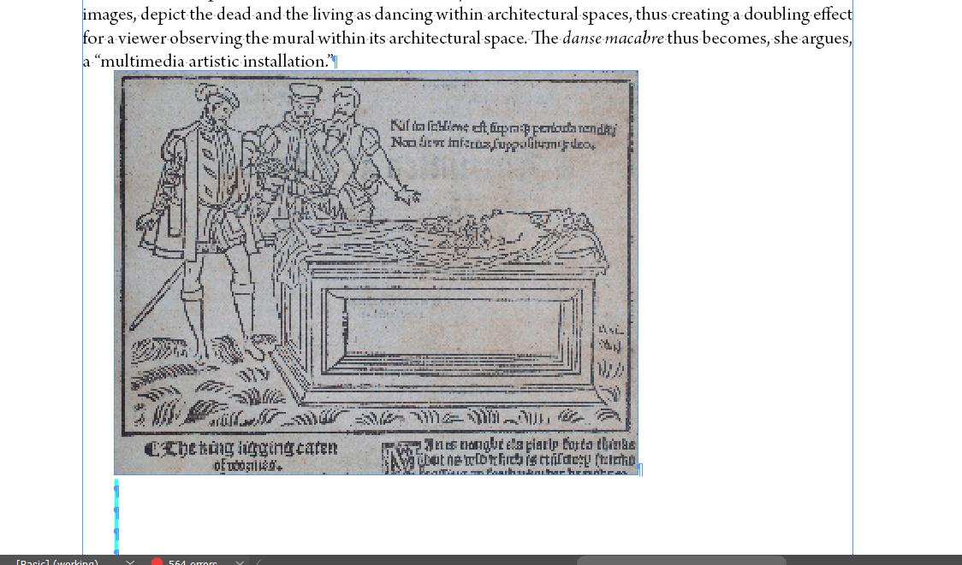

## CORRECT: This is what an image looks like when it’s been properly imported:

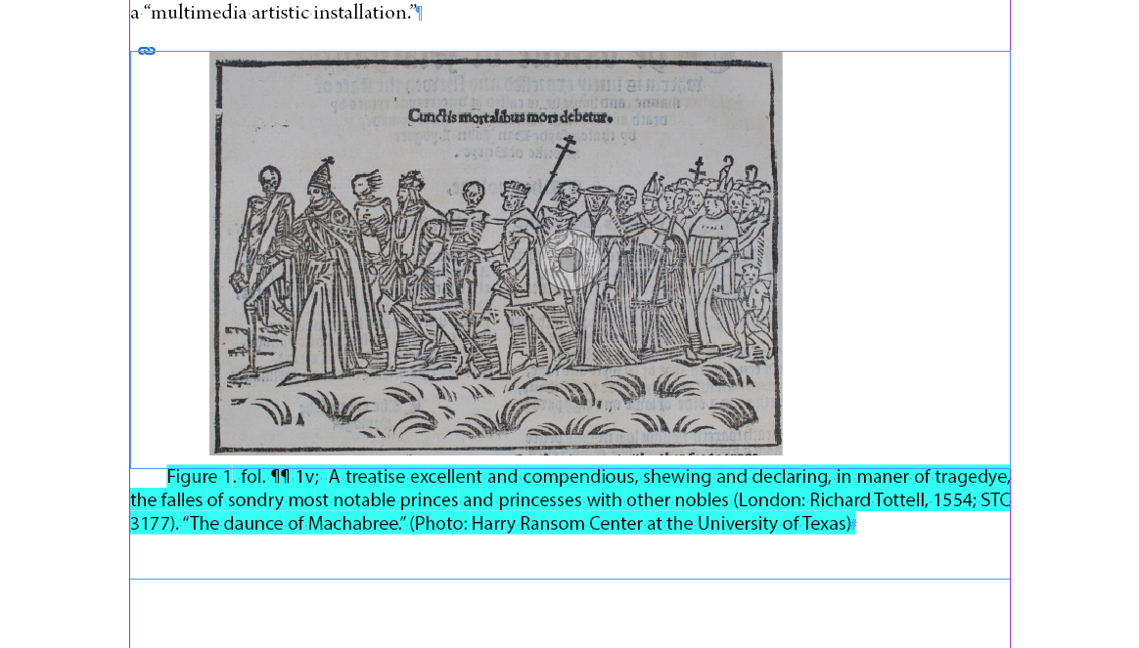

## Image Resolution

Once you start importing images, you may need to change your InDesign settings so that you see the correct resolution. If the images are pixelated, it’s likely because your display resolution is on a low setting in order to improve performance. While formatting images, it’s a good idea to set the object display on high (see image below), which will show you what the images will actually look like in print.

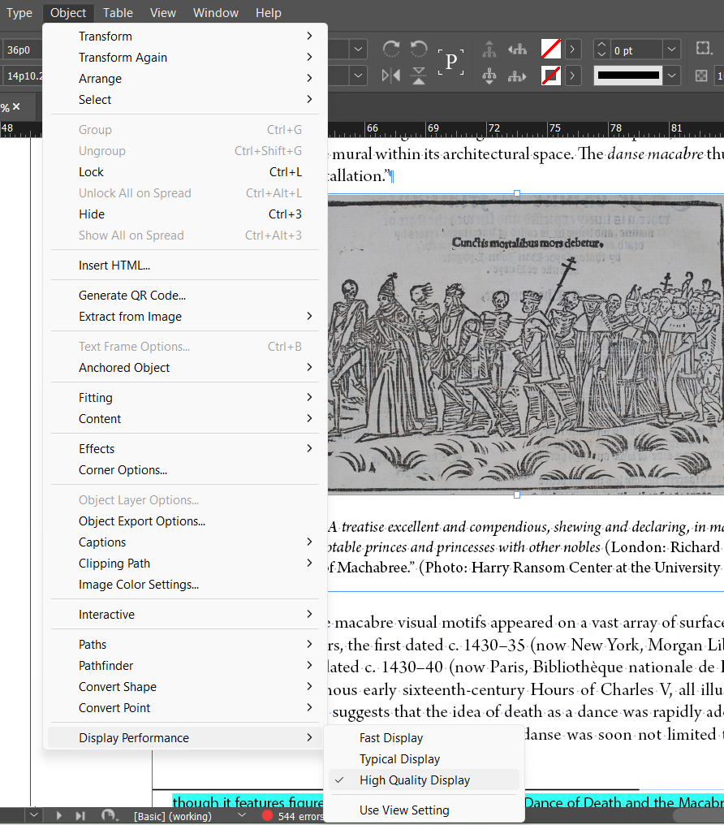

# Images with surrounding text on the same page

Format the text you are working on up until you reach the place where the image needs to be inserted. The volume editor will mark this with bracketed/highlighted text, such as [PLACE ILLUSTRATION 1 HERE].

## Make the image’s text frame and import it

* Using the text tool ([T] in left menu), draw a text frame off to the side of the page you are working on.
  + Note, if you try to create a new frame directly on top of where you want to place it in the text, it will be difficult to format because the text will just run behind your new text frame.
* Switch to the Selection Tool and click on the text frame, which will cause the boxes at the edge of the textbox to light up.

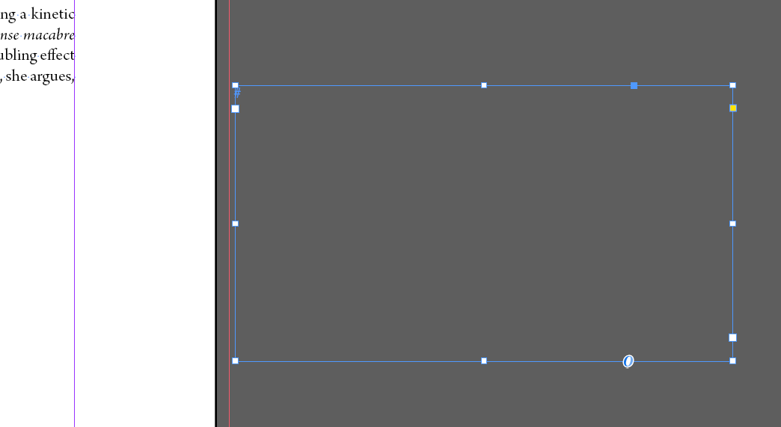

* Place the image inside the text frame in the same way that you place documents: Ctrl+D.
* When File Explorer pops up, navigate to the correct folder in Box and select the correct image file. Make sure the title of the image matches the description in the volume editor’s insertion note.

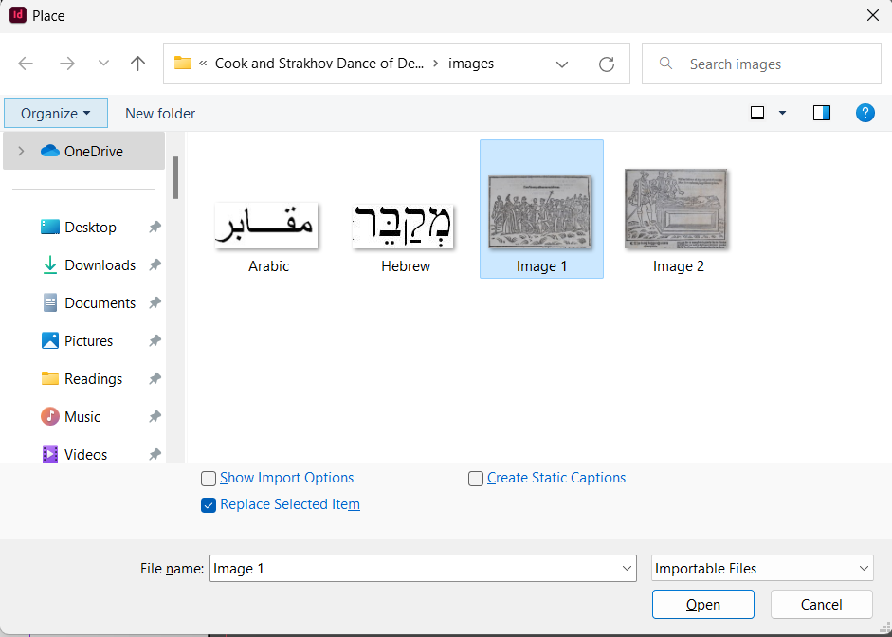

The image will likely import strangely, most likely extremely zoomed in and/or pixelated:

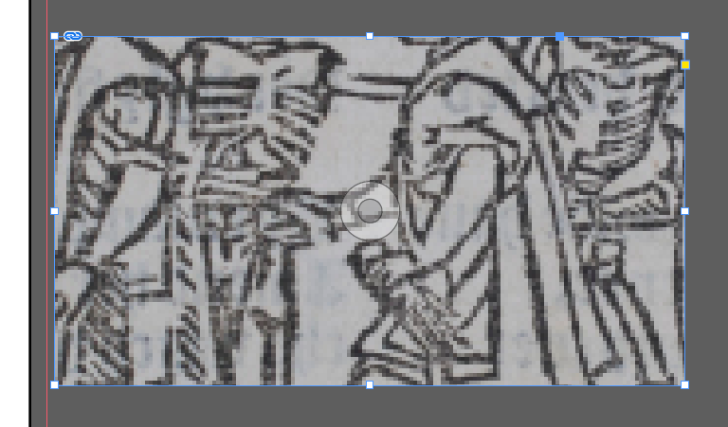

The image has imported correctly, despite its appearance. The link in the upper left corner means that it’s correctly linked. You will need to resize the image in order to make it display properly.

## Resizing

* Select the image and go to Object → Fitting → Fit Content Proportionally.

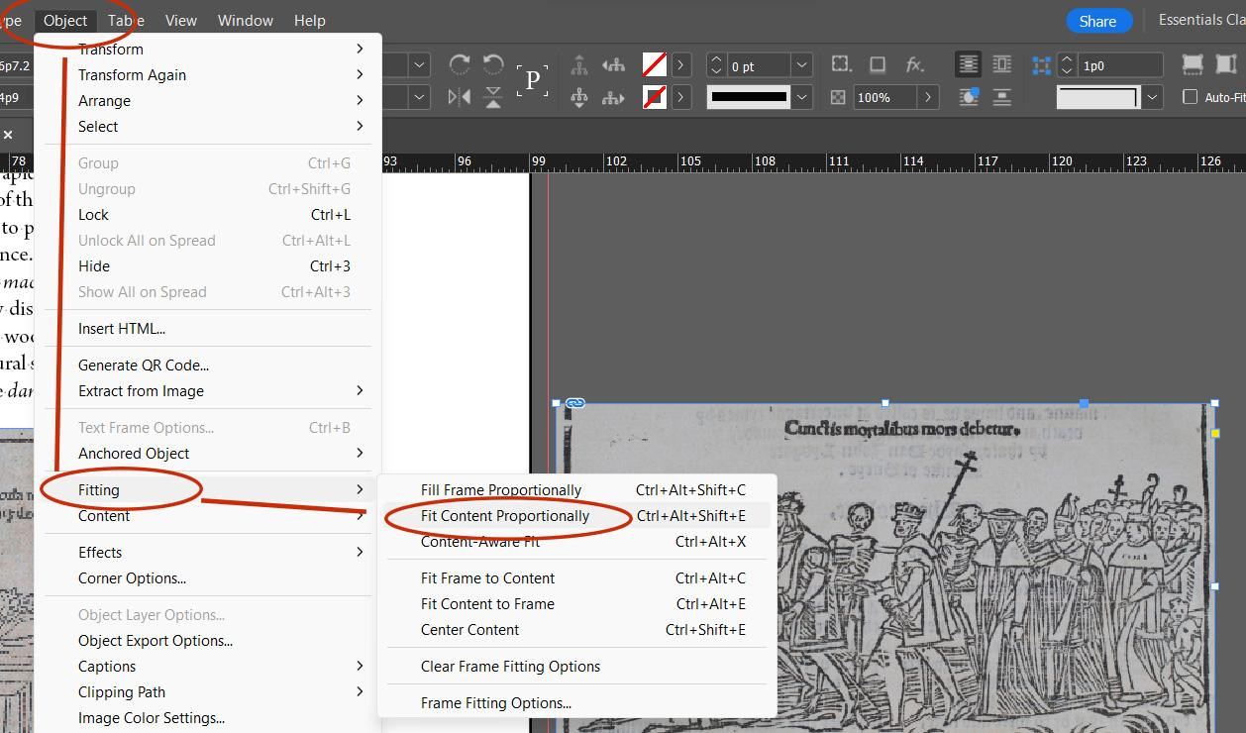

This will cause the full image to display in the text frame (see below). If you adjust the size of the text frame (which you will do when you place it on the page), you will need to redo the fitting steps, as the image will not adjust automatically.

# Add Image Caption

* Make a second text frame, for the caption to the image. This should be roughly the same length of the image text frame, though you will also resize this when placing it on the page.
* Copy and paste the caption text into the new text frame. Apply the Caption Paragraph Style.
* Resize the text frame as needed so that the caption is not overset.

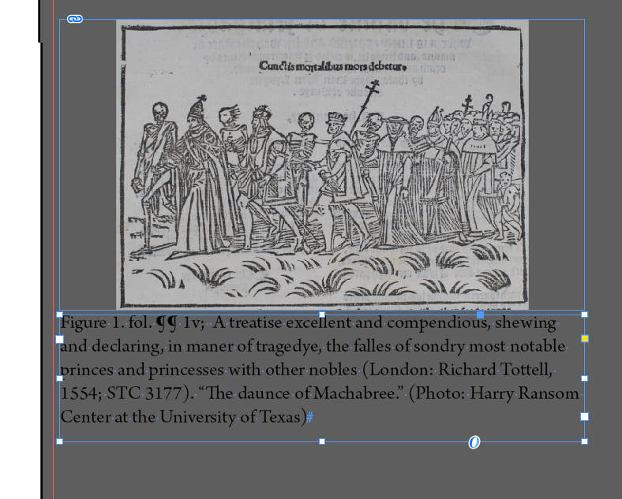

# Position the image and caption on the page

You will need to move each text frame separately.

* First, check the text-wrap settings on the image and caption text frames. You will need to change the settings so that the text on the page wraps around the new text frames. Otherwise, the new text frames will just be superimposed over the text on the page.
* Use the Selection tool to click into the image box
* In the top menu, select the “Wrap around bounding box” setting, which will cause external text to wrap around this box.
* Repeat for the caption.

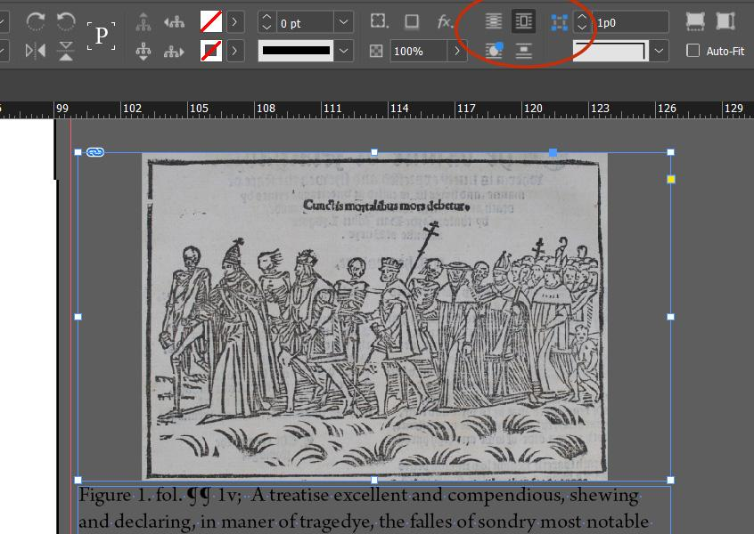

* Using the selection tool, click anywhere into the image text frame.
* Drag the image onto the page.
* Reference the Word Document to determine where the volume editor wants this image placed.
* Extend or decrease the vertical margins until they align perfectly with the page margins. The margins will turn light green when they are perfectly overlapped.

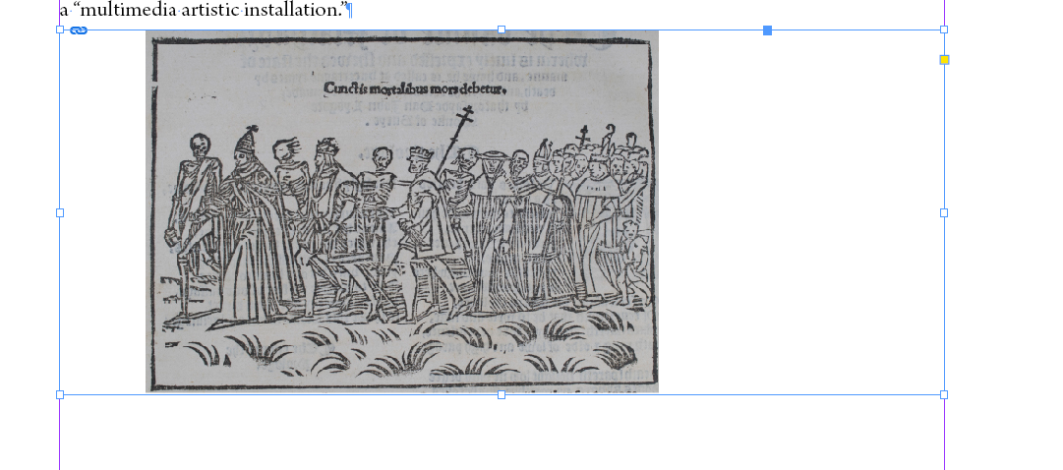

## Center the image

At this point, you may also need to center the image.

* Go to Object → Fitting → Center Content

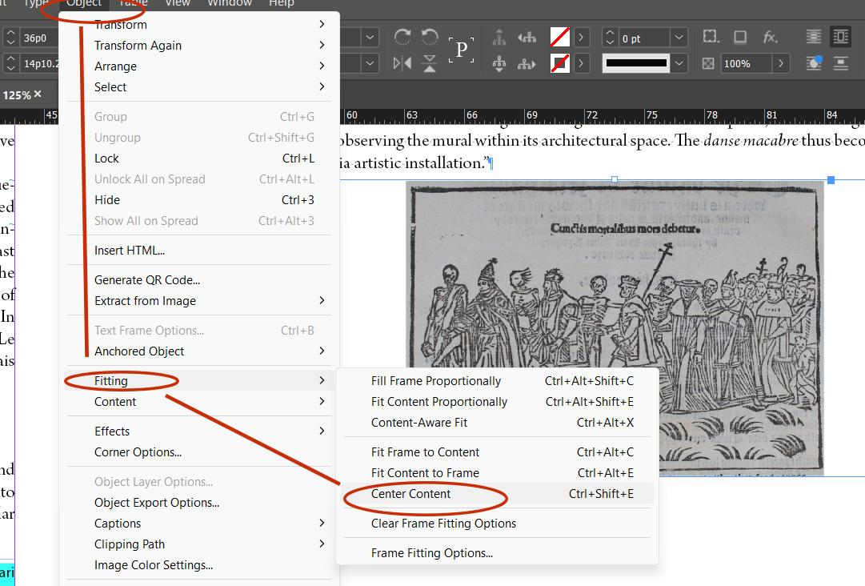

## Position caption under image

Once the image is set, repeat these steps with the caption.

* The top of the caption text frame should align perfectly with the bottom of the image text frame.

## Adjust Text Frame Spacing:

In order to make sure that there’s enough space between the caption and the image, you need to adjust the text frame spacing.

* Select the new text frame using the selection tool
* Right click > Text Frame Options > General
  + Inset Spacing: Make sure to break the link in the center of the inset spacing section. We don’t want all the spacings to be the same.
    - Set the Top to 1p3 spacing
    - Set the Bottom to 1p3 spacing

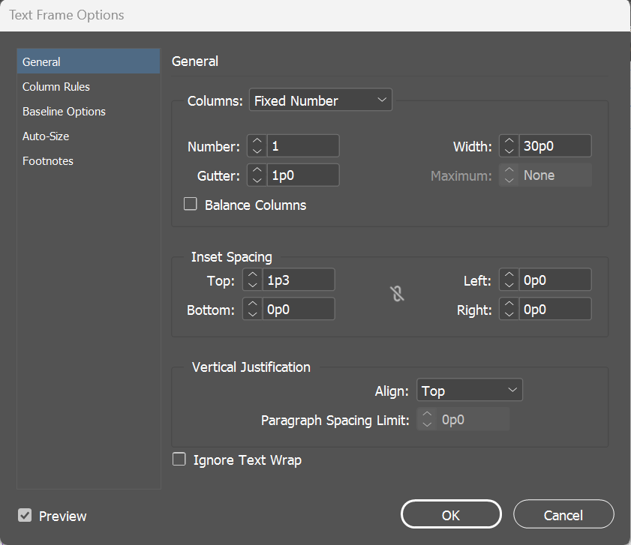

After completing the image and caption adjustments, check with Managing Editor for approval about placement and size and adjust accordingly. Be sure to add the image to the Table of Contents, along with the page number.

# Full-Page Image at the end of a document

For full-page images, format the entire text up to the page on which the image will appear. For that page, you first need to unthread that text frame from the text frames that came before this one.

If you want to be sure that your text frames are threaded correctly, you can turn on an option to view text threads:

* View → Extras → Show Text Threads

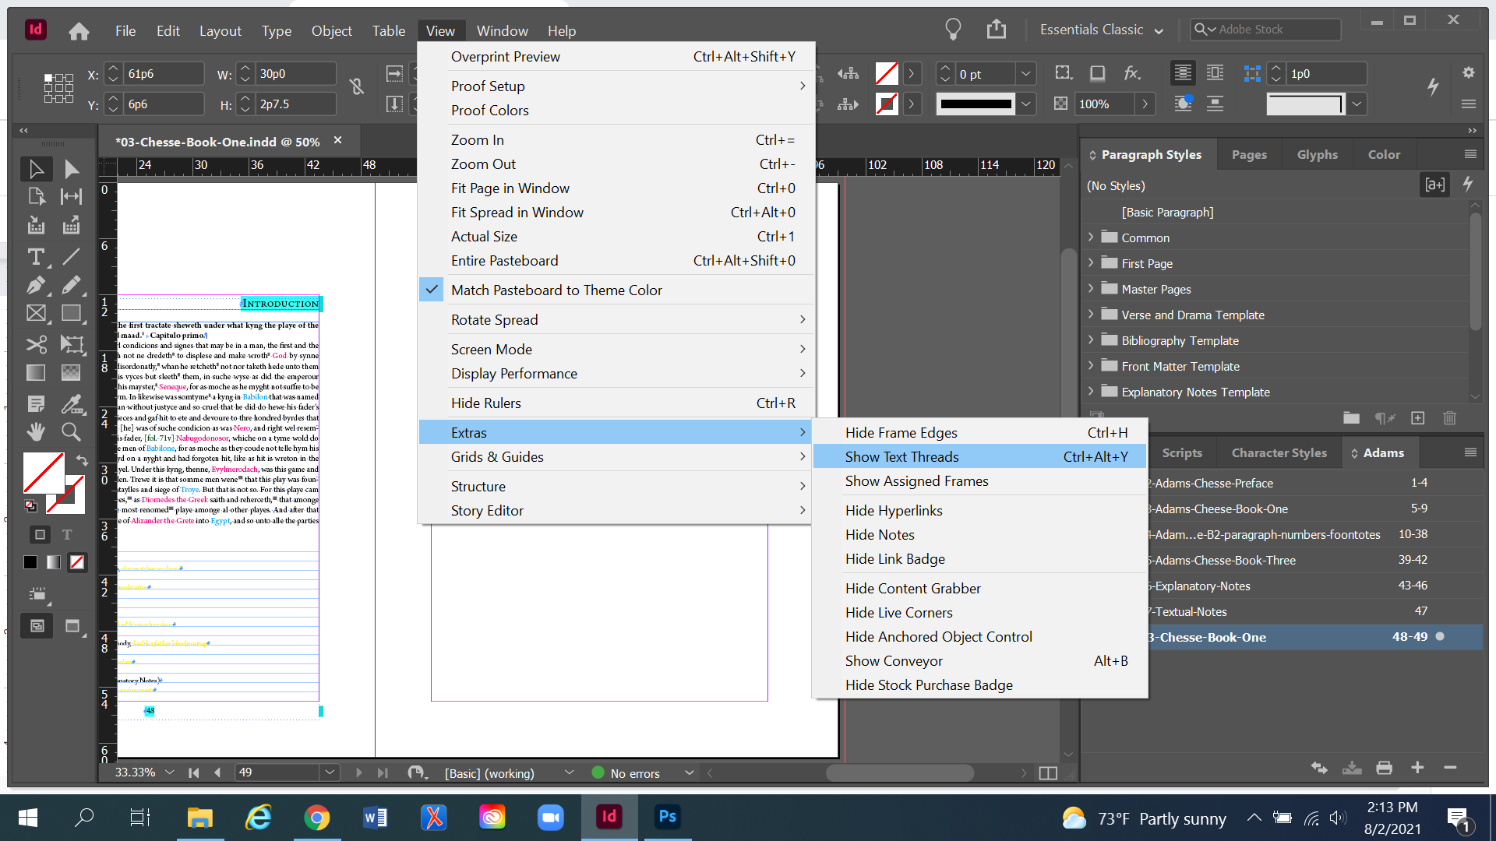

* After this setting is turned on, InDesign will show that frames have been threaded together by showing a blue line connecting the bottom of one frame to the top of the next frame. This thread only becomes visible if you are using the Selection Tool and have clicked onto a particular text frame.

## Un-threading a frame

* With the Selection tool, click into the “in-port,” (circled below) and then click into the blank page
* You will know if the text frame is un-threaded if there is no longer a blue line connecting to the in-port on this text frame.

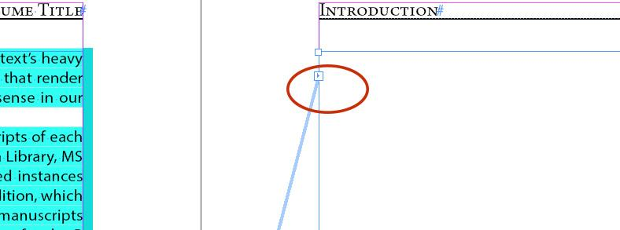

Place the image inside the text frame in the same way that you place documents, Ctrl+D. When File Explorer pops up, navigate to the correct folder in Box and select the correct image file.



The image will likely import strangely, most likely extremely zoomed in and/or pixelated:



The image has imported correctly, despite its appearance. The link in the upper left corner means that it’s correctly linked. You will need to resize the image in order to make it display properly.

Make sure you have the image selected and go to Object → Fitting → Fit Content Proportionally.



This will cause the full image to display in the text frame (see below). If you adjust the size of the text frame (which you will do when you place it on the page), you will need to go through the fitting steps again, as the image won’t automatically adjust.

To add a caption, you will need to click onto the bottom of the text frame and drag it partway up the page. Then draw a new text frame from the bottom margin of the page up to the bottom of the image textbox. Then copy and paste the caption in. Apply the Caption Paragraph Style.

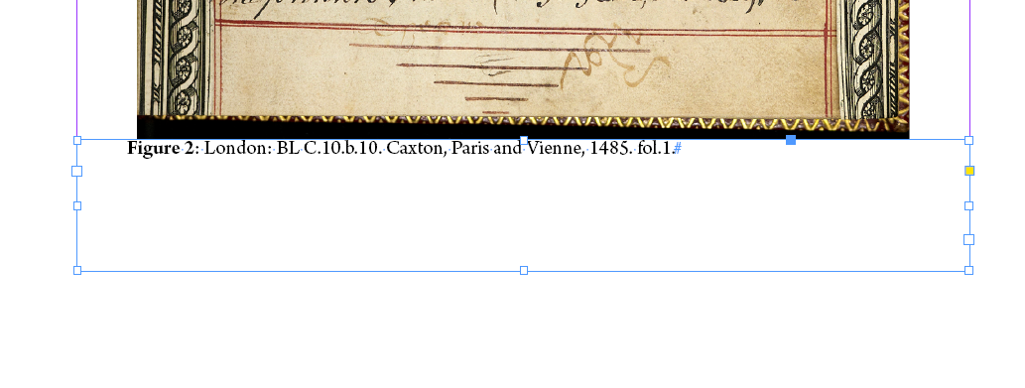

## Adjust Text Frame Spacing

* Select the new text frame using the selection tool
* Right click > Text Frame Options > General
  + Inset Spacing: Make sure to break the link in the center of the inset spacing section. We don’t want all the spacings to be the same.
    - Set the Top to 1p3 spacing



This is what the bottom of the full-page image should look like, once the captions have been added and the text frame adjusted:

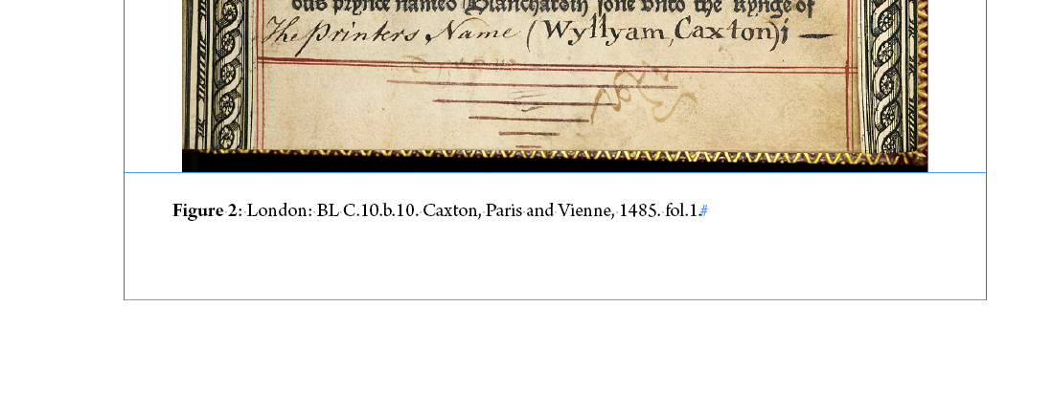

Check with the Managing Editor about the appearance of the image and caption before moving on. This is especially important if the image is on a full page that is not the last page of an InDesign document. Be sure to add the image to the Table of Contents, along with the page number.

# Full Page Image in the middle of a document (essentially, with text on pages around it)

To insert an image into the middle of an introduction, you first need to delete the existing text frame on the page where you want to insert the full page image.

## Remove existing text frame

* Click on the text frame using the Selection Tool, then use the Backspace or Delete button. The text from the frame will automatically reflow itself into the next text frame.
  + If the text on that page is a continuation of a paragraph from a previous page, click into the previous text frame at the start of the paragraph.
  + Then, insert a Page Break at the end of the paragraph.
    - Right click > Insert Break Character > Page Break
* Once the text frame has been removed, draw a new text frame on the now-blank page, using the Type Tool. It should be the same width as the margins on the page.
  + Drawing this text frame by hand means that the frame will not be threaded together with the rest of the text.

## Insert the full-page image

* Place the image inside the text frame in the same way that you place documents, Ctrl+D.
* When File Explorer pops up, navigate to the correct folder in Box and select the correct image file.



The image will likely import strangely, most likely extremely zoomed in and/or pixelated:



The image has imported correctly, despite its appearance. The link in the upper left corner means that it’s correctly linked. You will need to resize the image in order to make it display properly.

Make sure you have the image selected and go to Object → Fitting → Fit Content Proportionally.



This will cause the full image to display in the text frame (see below). If you adjust the size of the text frame (which you will do when you place it on the page), you will need to go through the fitting steps again, as the image won’t automatically adjust.

To add a caption, you will need to click onto the bottom of the text frame and drag it partway up the page. Then draw a new text frame from the bottom margin of the page up to the bottom of the image textbox. Then copy and paste the caption in. Apply the Caption Paragraph Style.



## Adjust Text Frame Spacing:

* Select the new text frame using the selection tool
* Right click > Text Frame Options > General
  + Inset Spacing: Make sure to break the link in the center of the inset spacing section. We don’t want all the spacings to be the same.
    - Set the Top to 1p3 spacing



This is what the bottom of the full-page image should look like, once the captions have been added and the text frame adjusted:



Check with the Managing Editor about the appearance of the image and caption before moving on. This is especially important if the image is on a full page that is not the last page of an InDesign document. Be sure to add the image to the Table of Contents, along with the page number.